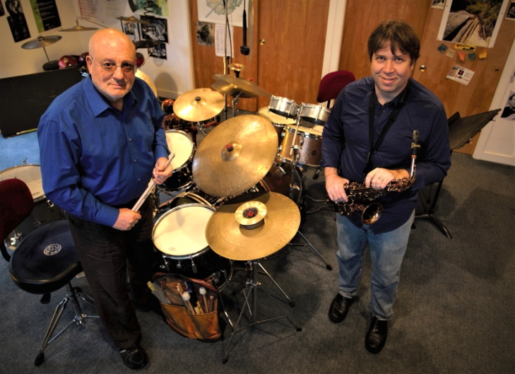
SnapDragon is an avant-garde jazz tour de force duo. Audiences are thrilled by the visceral and completely in the moment unique improvisations each concert experience offers. SnapDragon features the telepathic musical communication of Travis Sullivan on alto saxophone and piano, and Bob Meyer on drums. Inspired by the free improvisation explorations of Lee Konitz, Ornette Coleman, John Coltrane and Anthony Braxton, SnapDragon takes the concept of improvisation as spontaneous composition to a brand new level.

BIOGRAPHIES
Travis Sullivan has earned a worldwide reputation as an alto saxophonist, pianist, composer, and arranger. Embedded in the New York music scene for the past 20 years, he has been hailed by Jazz Times as being “…a gifted alto saxophonist and improviser who has also developed a strong and commanding voice as a composer.” In 2002, his breakthrough came in the form of Travis Sullivan’s Bjorkestra, which included performances with acclaimed jazz artists such as Dave Douglas, Kurt Rosenwinkel, and Donny McCaslin, Rachel Z, Clarence Penn, and George Garzone, and performances at the Montreal International Jazz Festival, the SF Jazz Festival, and the NYC Winter Jazz Festival. Travis has released six albums as a saxophonist, pianist, composer, and arranger: Seas & Trees (2016), I Go Humble (2013, Zoho Music), New Directions (Posi-Tone, 2011), Enjoy! (2008, Koch Records). and As We Speak (2000).
Bob Meyer has nearly 60 years experience as a professional jazz drummer. His extensive career has included working with Mal Waldron, James Moody, Gary Peacock, Kirk Leitsey, Stanley Cowell, Diane Shurr, Art Davis, Perry Robinson, Bert Wilson, Judi Silvano, Nina Sheldon, Ratzo Harris, Cameron Brown, Denman Maroney, John Hart, among many others. Meyer can be heard as the drummer on Joe Lovano's Blue Note Release "Viva Caruso", various CDs of the late Bert Wilson including Endless Fingers on Arabesque. Jackalope, a band with the late John Abercrombie and Loren Stillman on "Saltier Than Ever" on Challenge Records, Steven Frieder's debut CD "After Time," the band alt timers "Crispr," and most recently on Judi Silvano's album "Lessons Learned." (the Zephyr Band) scheduled for release in 2019. and SnapDragon's "The Long and the Short of It: Duo Improvisations." also scheduled for release in 2019. Bob has taught drums for over 40 years both privately and as adjunct at such schools as The New School and Lehman College in NYC. He lives in Cortlandt Manor, NY. USA with his wife Jody.

